EX NO:2 | Chebyshev IIR Filter
 | 2.1. Design and Performance Evaluation of a Chebyshev Type-I IIR Low-Pass Filter using MATLAB

Objective1:
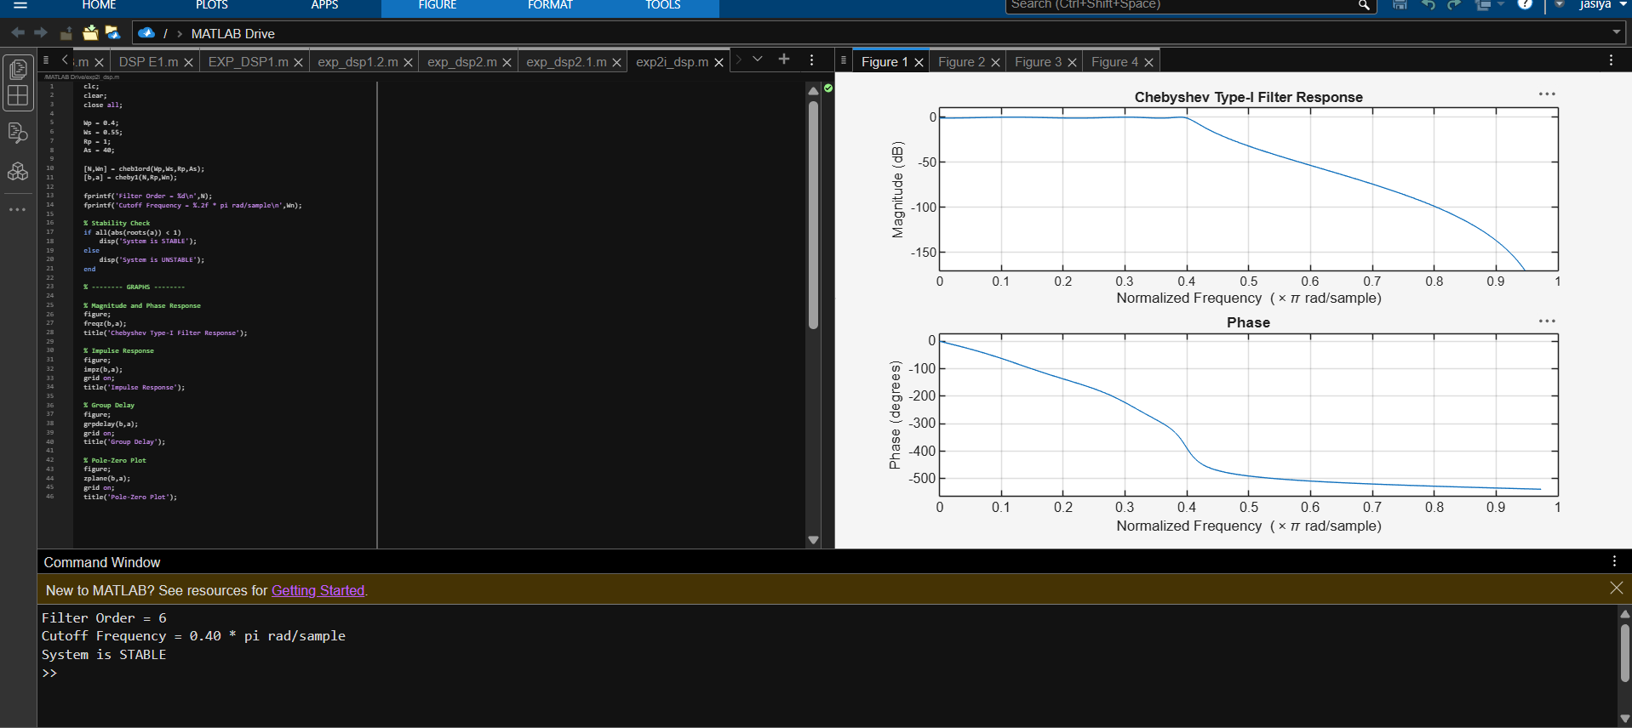
Objective 2:
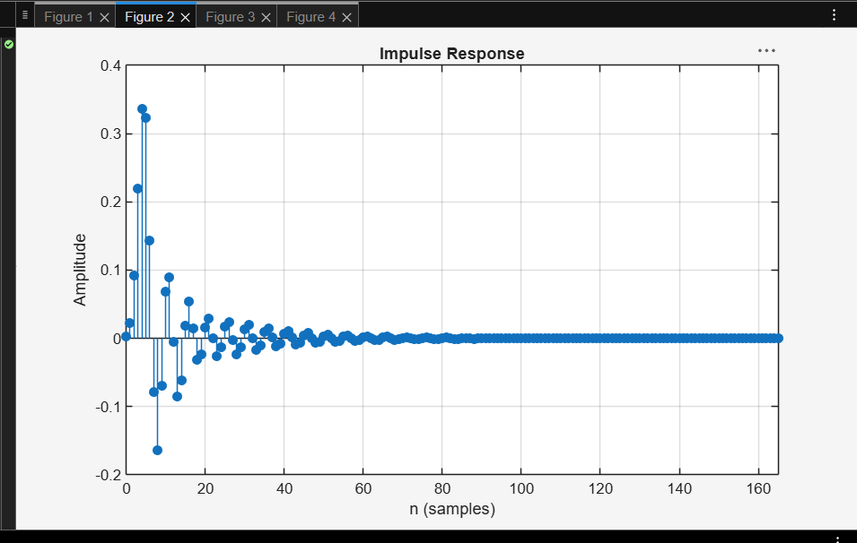
Objective 3:
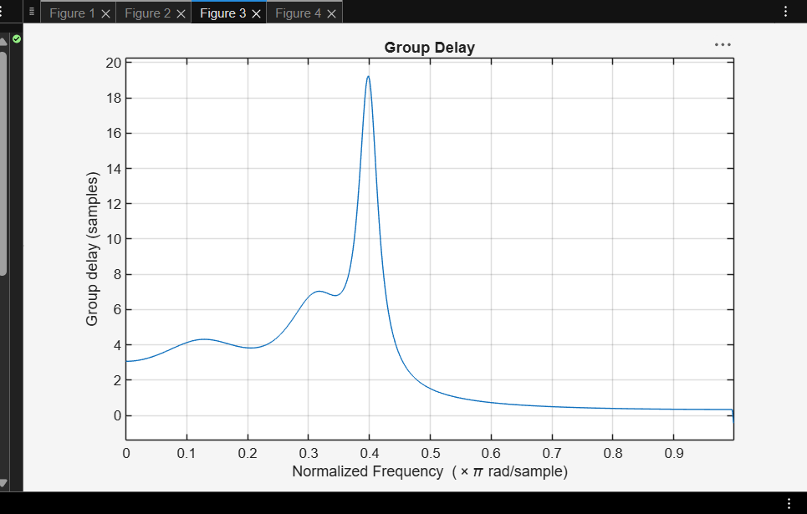
Objective 3:
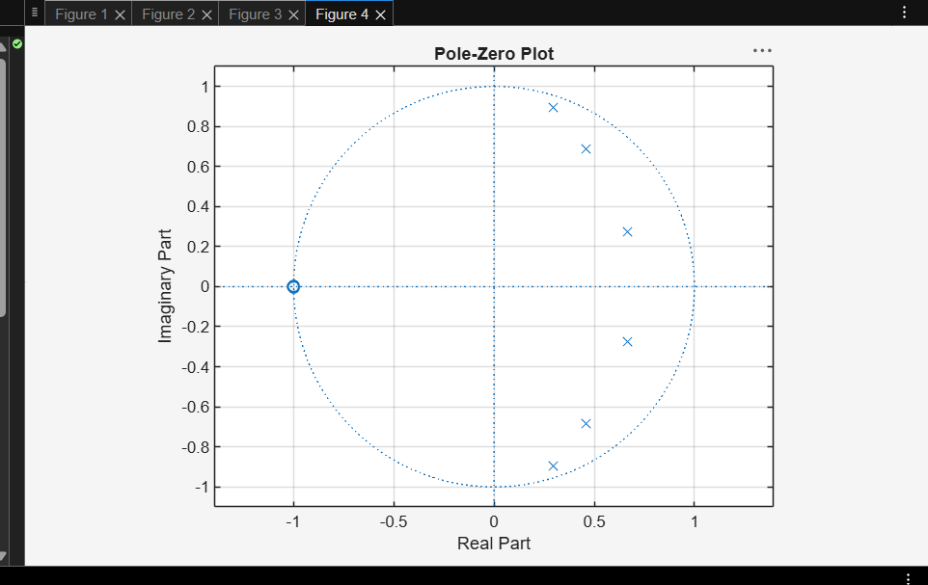

Result:
1. The Chebyshev Type-I IIR low-pass filter was successfully designed, and its magnitude response, phase response, impulse response, and group delay were analyzed. 2. The impulse response and group delay characteristics were obtained and found to satisfy the given specifications.
3. The pole-zero plot confirmed that all poles lie inside the unit circle, verifying the stability and proper performance of the filter.
4. The minimum filter order and cutoff frequency were successfully determined and found to satisfy the given design specifications.

EX NO:2 | Chebyshev IIR Filter
DATE: | 2.2. Design and Performance Evaluation of a Chebyshev Type-I IIR High-Pass Filter

Objective 1:
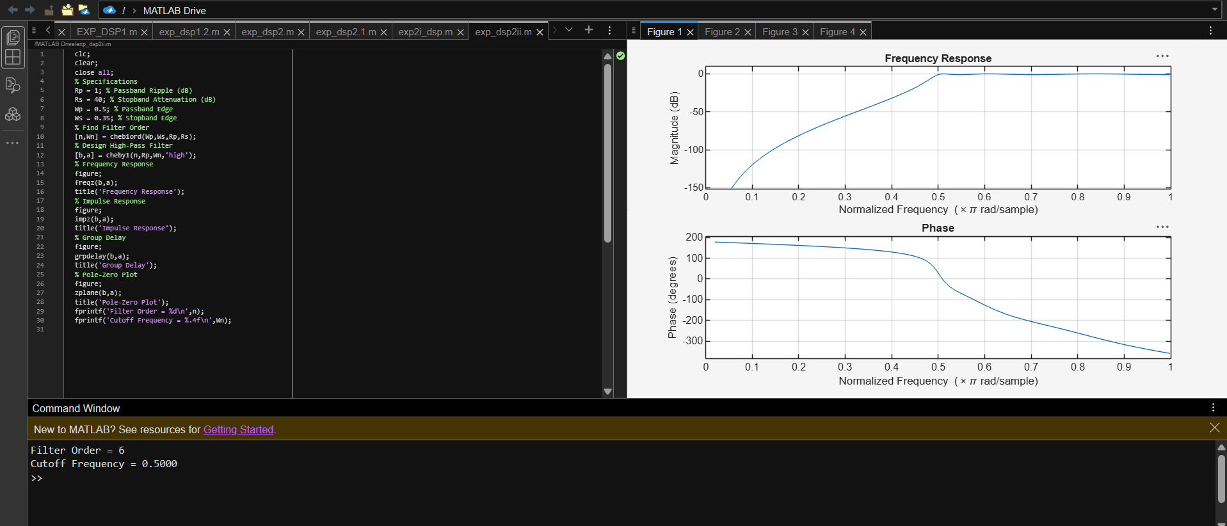

Objective 2:
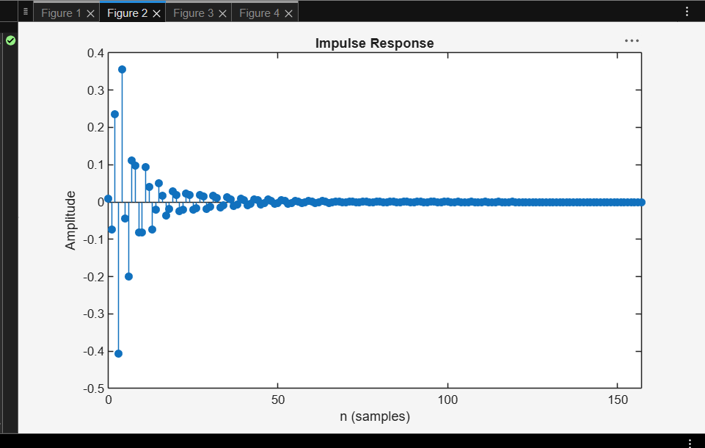
Objective 3:
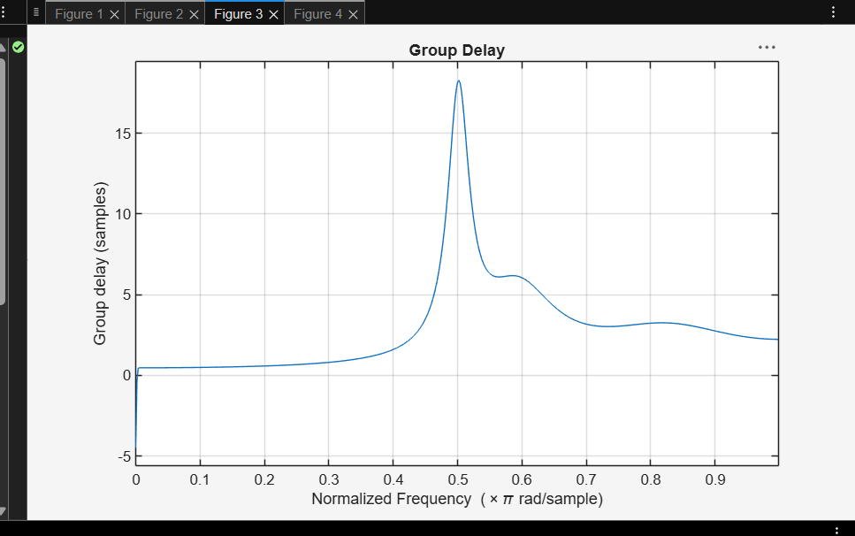

Objective 4:

Objective 5:
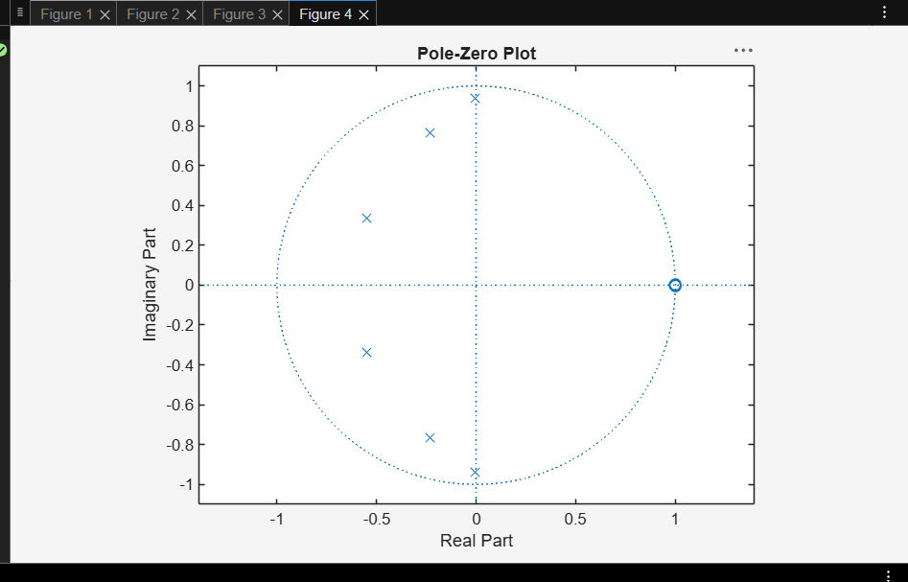

Result:
1. The Chebyshev Type-I IIR High-pass filter was successfully designed, and its magnitude response, phase response, impulse response, and group delay were analyzed. 2. The impulse response and group delay characteristics were obtained and found to satisfy the given specifications.
3. The pole-zero plot confirmed that all poles lie inside the unit circle, verifying the stability and proper performance of the filter.
4. The minimum filter order and cutoff frequency were successfully determined and found to satisfy the given design specifications.

